Teacher-Student Roster Verification
The purpose of this document is to guide teachers through the Teacher-Student Roster Verification process. Section 30-2.3 of the Rules of the Board of Regents requires teachers and principals to be involved in the review and verification of linkage data.
STEP 1: Login - Access the login page at https://eservices.nysed.gov/taa/login.htm
If you have already created an account (for roster verification last year or for ePMF/BEDS), you will log in to the TAA System with the same username and password. Please note that PINs are no longer being generated. Teachers can now create and reset their own accounts utilizing their staff emails.
Tokens are generated for teachers who do not have active TAA accounts or require an account reset. For teachers with current active accounts, no action will be required unless you cannot recall your password and security questions and need to reset your account. After requesting an account reset, you will receive an email which will guide you in utilizing the new Token process. The teacher clicks on the link with the token and is directed to the TAA system and begins the account creation or reset process. If you do not already have an account, click on the “I need to create an account link”.
STEP 2: If you have previously created an account, enter your Username and Password and skip ahead.
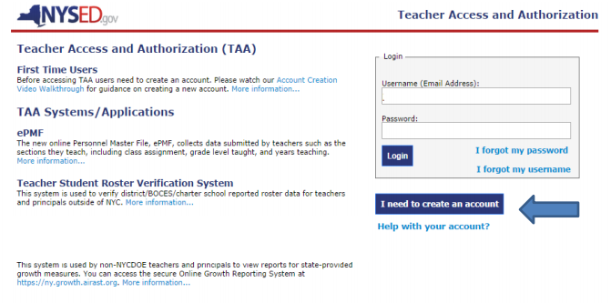
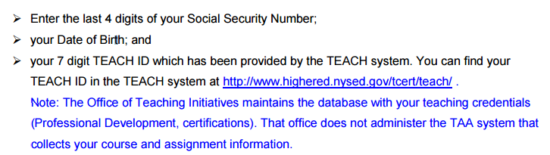
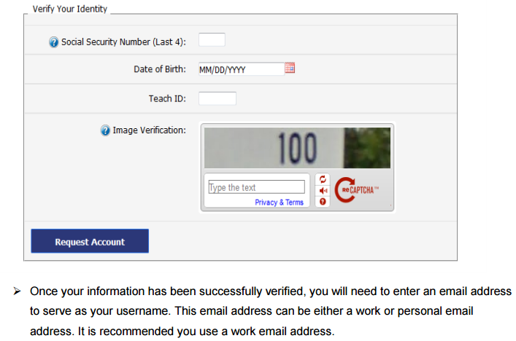
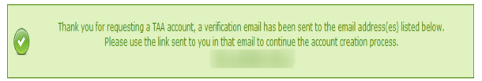
Step 3: Check your work email and click the link (token).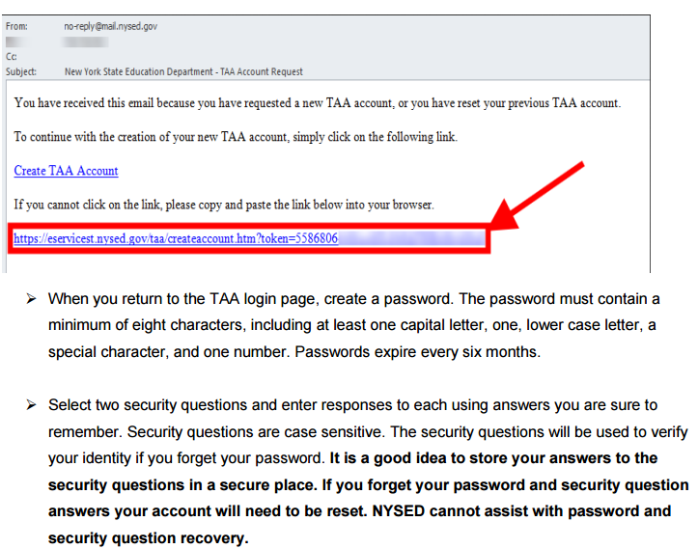
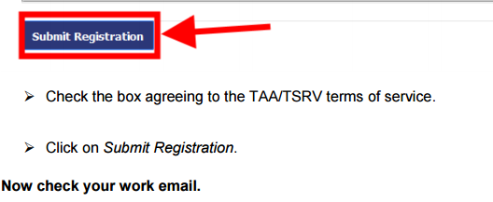
RESETTING YOUR ACCOUNT:
When you cannot access your account because you forgot your password or username, and you cannot remember the answers to your security questions, your account must be reset.
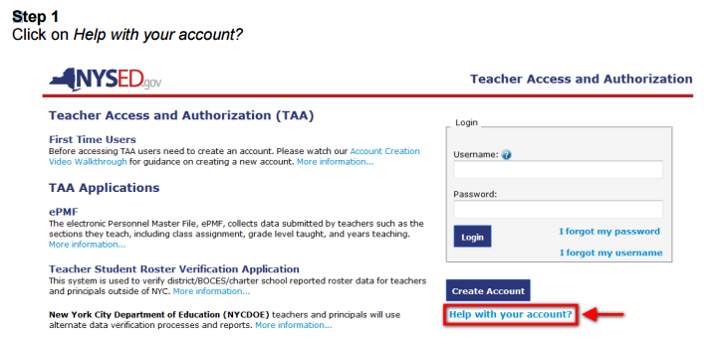
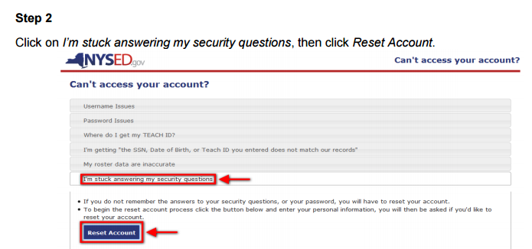
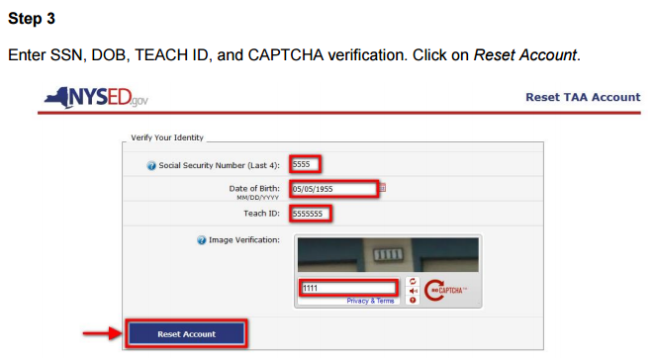
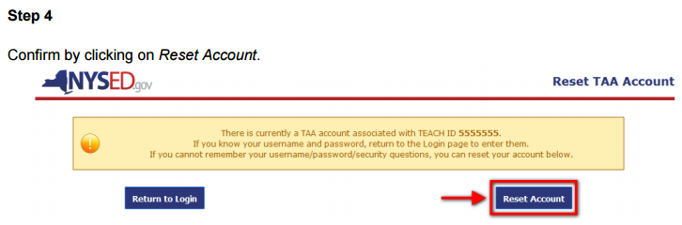
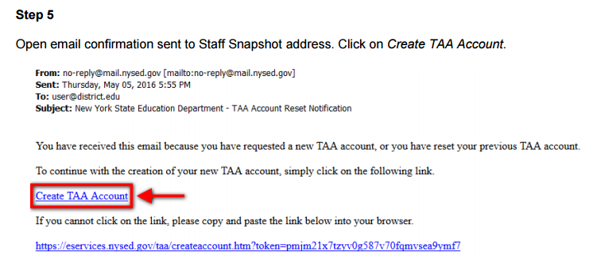

REVIEWING YOUR ROSTER DATA
On the TSRV welcome page, you will want to use the dropdowns to display data for a particular year, school, course, and/or section. In the example below, you have the option to select which course you want to view data for (e.g. Grade 4 English Language Arts, Mathematics). If you teach in multiple schools you will see the various schools listed for you to choose from. If you teach multiple sections of a course then you will use the dropdown menus to choose which section you want to view data for. Each year will contain data for all the schools you were assigned to during that school year.
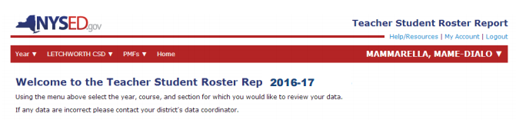
Once you make your year, school, course, and/or section selections you will be brought to the corresponding report.
In prior years, all courses were displayed with both assessment dates and end of year dates (e.g. April and June).
Since only courses linked to state assessments are reported here in 2016-17, they will automatically display an Assessment Snapshot date. Please be sure to verify the Linkage Start and End Dates.
If you do not see data that you are expecting or there are inaccuracies, please work with your Principal to correct the issue. Corrected data can be viewed after it is uploaded to the NYSED data warehouse.
